Title or Task: | Basic Drawing in Word  

Description:

Files Required
Suitable for Classes: | AIT • Multimedia • Cert II IT • Cert II Bus
Area: | Technology & Enterprise
Teacher: | Mr Peter Faulks

Timeline

Date Due:

Task Brief:

Outcomes:

Items highlighted in yellow are tasks for you to complete
Items in Blue italics are help tips

How to draw in word
Workshop Session
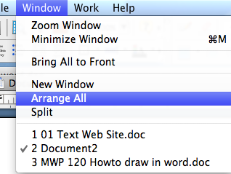

1– Create a header box

- Add a New Blank page then click on Window Arrange All so you can work on the blank page and see the instruction page split below.

Click on View Toolbars and show Drawing

- Click on the Rectangle button in the Drawing Toolbar

- Move the mouse to the page then click, hold and drag the mouse over the page.

As you drag the mouse, the outline of the shape will appear.

- Release the mouse when you are satisfied with the size
- Double click on the object or click once on the object and from Format click on Autoshape
- Add a pattern colour to the rectangle and a fancy line
- Insert Word Art and type Welcome to and select a font that is fancy
- Insert a text box make it no fill and no line
- Type your first name Peter’s make this a block font
- Cut the first letter (P) and paste this into another text box make this larger then transparent fill and line and place it over the remainder of your name
- Insert a text box make it no fill and no line
- Type your last name Portfolio and make this a serif font like Times
- Cut the first letter (P) and paste this into another text box make this larger then transparent fill and line and place it over the remainder of your name
- Move the elements around to look something like my sample but with your name and colours



Typing your Name in Full use some of these exersizes to create a cover for your Portfolio
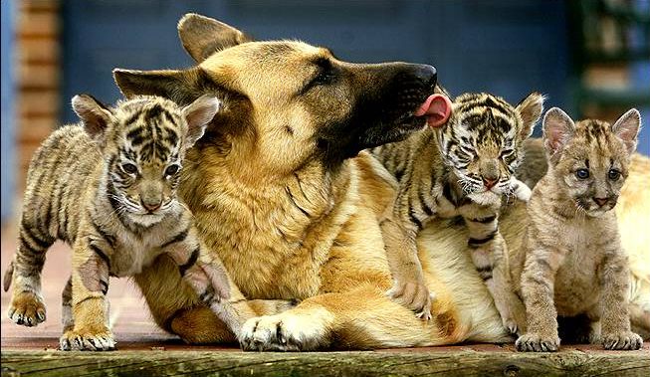

2007
Portfolio
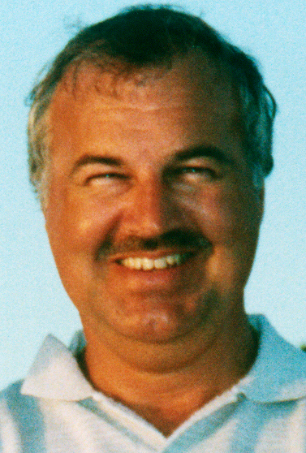

Drawing and WordArt

Drawing can help create interest in a presentation. Drawing tools can also be used to create diagrams and schemes. Drawing tools include shapes, lines, and text boxes.
Enter Text
Proof Text
Preview Text
Print Text

WordArt is a great way to format text to give it extra special impact.

WordArt
is fabulous for

extra special formatting

In this section you will

- Create Drawing Objects
- Create WordArt Objects
- Format and work with Drawing and WordArt Objects

The Drawing Toolbar

All the examples on the introduction page were produced using the Drawing Toolbar.

The Drawing toolbar is usually located at the base of the screen.

- If you cannot see the Drawing toolbar click on View ➢ Toolbars ➢ Drawing to display it

To Draw an Object

We will start with some basic shapes then move onto some of the AutoShapes.

- Repeat the procedure for the Oval and Line buttons. You could try to draw the example below

Using no lines and white fill you can create some nice effects, create one now try some gradient fills...

Editing the Roundness of an Arc

We change the roundness of an arc line by dragging the line to the required shape.

- Position your pointer on the arc line and click to select it

Resize handles will appear around the line

- Click on the left resize handle and drag further to the left

As you drag a broken line will indicate where the line will be and the shape it will take if you release the mouse at that particular point.

- See if you can edit the arcs to appear as below.

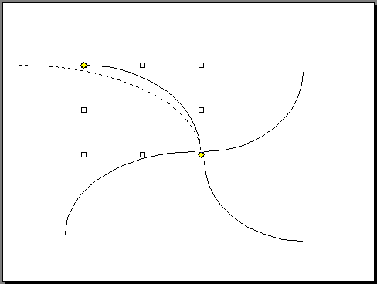

Edit the Angle of an Arc

So far the Arcs we have created are only the curve of an ellipse for an angle of 90 degrees. We can increase or decrease the angle of the curve, ie an arc that was virtually a circle would have an angle of nearly 360 degrees.

To change the angle

- Resize the arc to small as shown below

- Click on the yellow handle at the end of an arc line - a handle will appear at each end of the arc line

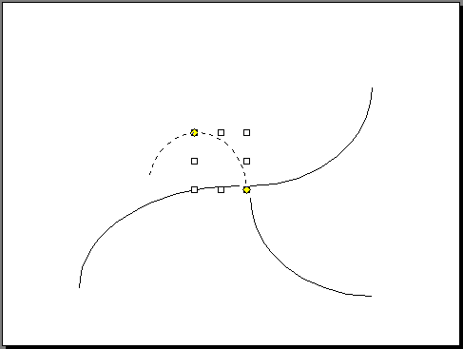
- Drag one of the handles around to increase the angle of the arc

- Click anywhere off the line to deselect it

- Try to form the shape shown to the left with the four arcs you produced before - you may need to change the roundness as well to get the four small circles

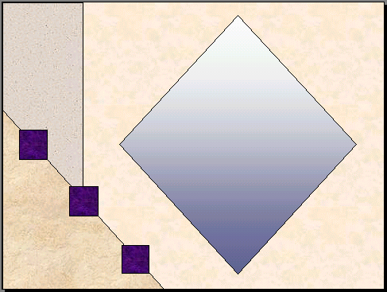
- Start a New presentation with a Blank page layout

- Use the drawing objects and stacking features to create this page that could be used as a background

- Save the presentation as Background

- Close the file when finished

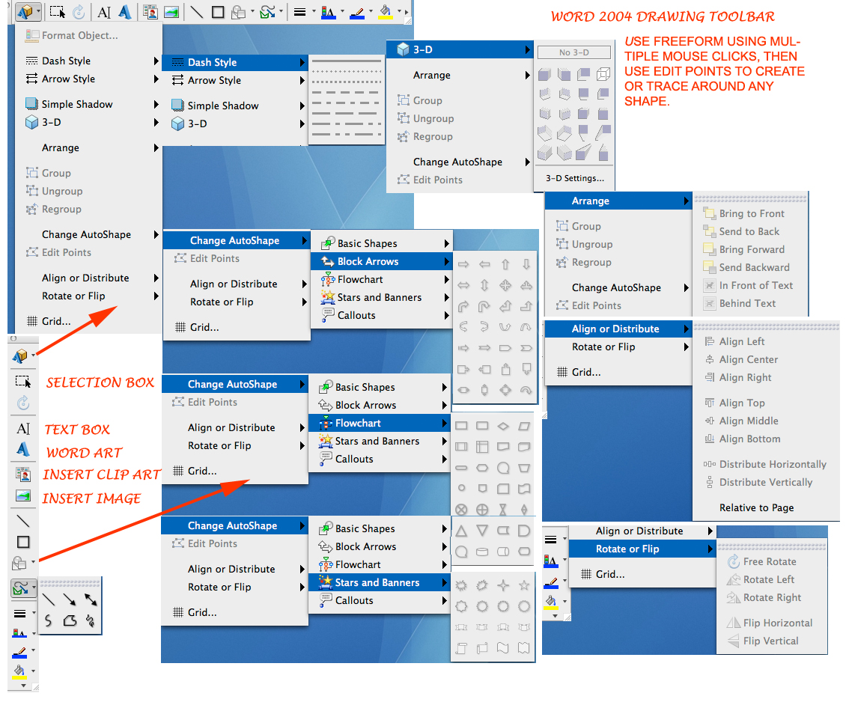
Text Boxes (Locking)

Open the Microsoft Word document that contains the text boxes that you want to lock. Right-click on the text box you want to lock and then click on the “Format TextBox” option.
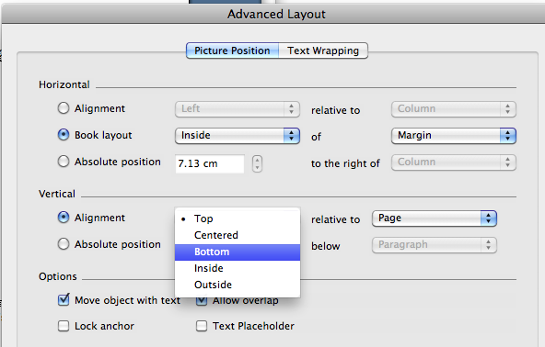

Click on the “Layout” tab and then click on the “Advanced” button. Select the “Alignment” option below the “Vertical” heading and then select the “Bottom” option from the drop-down menu.

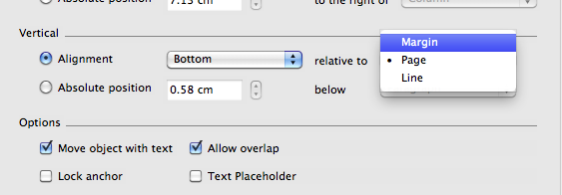

Select the “Margin” option from the drop-down menu next to the “relative to” field. Click on the box next to the “Move object with text” field so that it’s deselected.

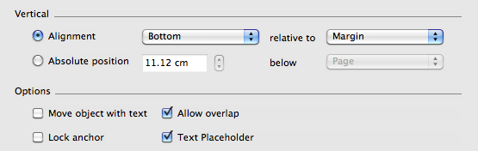

Click on the box next to the “Lock anchor” field so that it’s selected. Click on the “OK” button.

Move your cursor about the text box. Click on the “Insert” option from the top toolbar menu and then click on the “Break” option if you’re using Word

2003. Click on the “Page Layout” tab and click on the “Breaks” icon for Word 2007.

Select the “Continuous Break” option. Click on the “Tools” option and then click on the “Protect Document” option for Word 2003. Click on the “Review” tab and click on the “Protect Document” icon for Word 2007.

Click on the “Select sections” option and then select the section of your document where your text box is located. Click on the “OK” option and then click on the “Yes, Start Enforcing Protection” button.

Wrapping through an object

- Select the picture. Use Transparent Colour to remove background



Edit Wrap Points without transparent colour removed
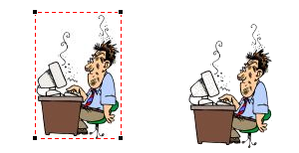
Edit Wrap Points with transparent colour removed
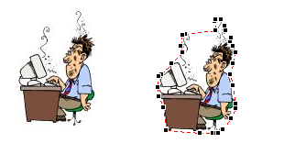
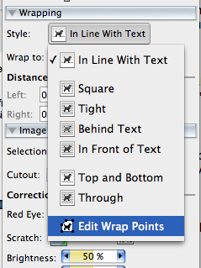

- Click the Text Wrapping tool in the Picture toolbar and select Edit Wrap Points from the drop-down list.

- Use the dashed red line that appears around your picture to change the border by clicking and dragging one of the handles with the mouse pointer to where you want the edge to be.

- Continue adjusting the points around the picture until the text is correctly positioned around the picture. The text will adjust accordingly.



